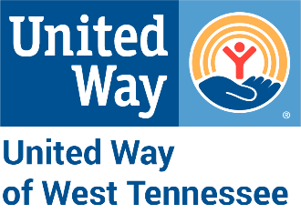
FOR IMMEDIATE RELEASE
Media Contact:
Katherine Cheshire
kcheshire@unitedway.tn.org
731-265-6756

United Way of West Tennessee and The West Tennessee Healthcare
Foundation Sponsors Parkview Prep Academy’s Library Transformation

Jackson, Tenn. (April 19, 2022) – Jackson-Madison School System, United Way of West Tennessee, and The West Tennessee Healthcare Foundation are excited to announce the completion of a collaborative renovation project at Parkview Prep Academy.
As Jackson-Madison County School System’s alternative school for students with various needs, Parkview Prep Academy proposed to renovate its library into an improved academic space for increased student engagement.
After observing that students needed a stronger sense of belonging, greater access to technology, and a safe, collaborative learning environment, Parkview teachers envisioned a Learning Commons, sponsored by United Way and The Foundation. The Commons provides a welcoming, inclusive environment to nurture student connections. Additionally, it gives students greater access to important technology and encourage collective learning in a safe, precautioned manner.
The Parkview committee recommended providing new furniture, computers, iPads, books, TV, and other items, with a projected cumulative project cost of $20,000. This equipment will help ensure Parkview students receive more opportunities for success as inequities are removed.
The proposal stems from JMCSS Superintendent, Dr. Marlon King, and his vision for a more equitable and sustainable future through the School New Normal Initiative. With education as one of its key organizational pillars, United Way was excited to support this initiative with The Foundation. Together, these organizations are committed to building a more educated and resilient community.

About Jackson-Madison County Schools
The Jackson-Madison County School System is a diverse and forward-thinking school system that provides equitable options and opportunities in a safe, caring environment to maximize student potential.

About United Way of West Tennessee
Established in 1941, United Way of West Tennessee is a nonprofit organization in Jackson, Tenn. that advocates for equity through uniting agencies in ways that improve each person’s access to health, education, and financial stability.

About West Tennessee Healthcare Foundation
The West Tennessee Healthcare Foundation was established in 1985 to strengthen the health and well-being of our region by serving as a catalyst for positive changes in healthcare, education, the arts, and other causes. It provides philanthropic support for West Tennessee Healthcare and its eighteen-county service area, and it enhances the quality of life for local residents by supporting programs, initiatives, and organizations serving rural West Tennessee.

###

