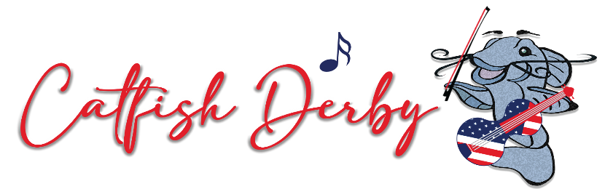

1st Annual Catfish Derby Benefit Concert

September 24, 2022

On Saturday, September 24, 2022, The Hardin County Leadership Class of 2021 will kick off the 1st Annual Catfish Derby Benefit Concert in Historic Downtown Savannah, Tennessee. During this one-day celebration of great music, great food, and fun, attendees can enjoy live music by some of the best bands that have not only been established for years, but also rising in popularity at festivals across the area!
The National Catfish Derby and World Championship of Catfishing Tournament has been an annual staple in Savannah for many years. This spectacular event is the ‘granddaddy’ of all catfishing events. It does not just include fishing, but great family-oriented fun for all. The all-day tournament will be surrounded by food and craft vendors of all sorts, as well as a car show. As the fishermen end their excursion and begin to roll back into court square, everyone will have a chance to view their prize catches!
New to this year’s event will be the addition of the Catfish Derby Benefit Concert. This 1st Annual Benefit Concert is the result hard-work and “outside-the-box” thinking by the 2021 Hardin County Leadership Class. All proceeds from ticket sales will be directly allocated to assist local non-profit organizations or community emergency responses in Hardin County as needs arise.

Admission to the Fishing Tournament/vendors grounds is FREE! This will be open 8 am – 3:00 pm.

Admission to the Benefit Concert will begin at 2:00 pm and a ticket must be purchased to enter.

Tickets are on sale for $20. To purchase tickets to the Catfish Derby Benefit Concert, visit our website at https://www.eventbrite.com/e/catfish-derby-benefit-concert-tickets-344162658777 or purchase them in Savannah City Hall.
Again, all proceeds from ticket sales will be directly allocated to assist local non-profit organizations and/or community emergency responses in Hardin County as needs arise.
SCHEDULE OF EVENTS

FISHING:
Registration for the Catfish tournament will be Friday, September 23rd at the Historic Savannah Theater from 4-7 pm with no entry fee. The catfish tournament will begin on the morning of September 24th. The fishermen can start fishing at 6:00 am and must be in line for weigh-in by 3:00 pm. Weigh-in is held behind the Hardin County Courthouse and we encourage everyone to come out and see the catfish these fishermen reeled in out of the Tennessee River. For more information, you can contact JR Sweat at 731-610-9863.
MUSIC:
Bring a lawn chair, gather family and friends, and join us as we feature a full afternoon of music from a slate of popular bands, including Hardin County’s own, and headliner - Darryl Worley (Songs: Have You Forgotten, Sounds Like Life to Me, Awful Beautiful Life); Grammy Award Winning - Deana Carter (Songs: Strawberry Wine, We Danced Anyway, You and Tequila); Disney Springs’s Mighty Swell Band; Chandler Stephens; and Chelsea Rhodes. Saturday night’s music begins at 4pm and rocks until finished!
VENDORS:
Offering food and specialty items for purchase, vendors include Macye’s Grill on Wheels, Just Bite Me (Mini Donuts), Chillin’ It (Shaved Ice), Sweetie’s Gourmet Kettle Corn, Mollie Monday’s Restaurant, Liquid Hitch (alcohol sales) and a Budweiser Trailer, among several local craft vendors.
BEVERAGES:
All adults 21 and older who intend to consume alcohol will be required to show valid photo ID as proof of age upon entry to the concert. No outside coolers, food, or beverages will be permitted. The concert will feature open street seating and visitors are encouraged to bring a lawn chair; no seating will be provided. The Catfish Derby Benefit Concert will take place rain or shine.

For more information contact Timbo White at 731-607-2782 or Blake Walley at 662-801-8980.

