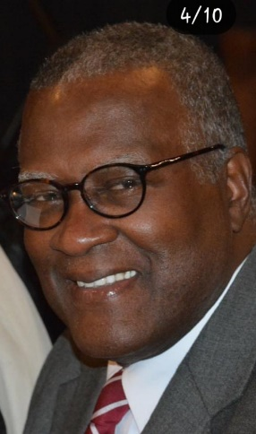

JACKSON, TN (August 19, 2022) – Atty. Richard Donnell, Sr. Advisor to the President at Lane College, has been awarded the Harold Love Outstanding Community Service Award by the Tennessee Higher Education Commission. He is one of five faculty/staff recipients across Tennessee’s higher education institutions to earn the service award.

As senior advisor, Donnell advocates for the college on federal, state, and local governmental affairs; assists the President in developing and promoting strategies to influence public policy priorities of Lane College at those governmental levels; and creates external communications to vital constituents and stakeholders of the college on a full range of strategic matters. He also serves as the project coordinator of Lane’s Second Chance Pell program, which offers degree-leading college credit courses to incarcerated persons at the Northwest Correctional Complex in Tiptonville, Tennessee. The goal of the project is to reduce recidivism and build a prison-to-college pipeline.

Donnell is also the host of two Jackson, Tennessee radio talk show programs on WFKX-FM and WLCD-LP.

“I am humbled and honored to receive this community service award from the Tennessee Higher Education Commission. To be recognized by such an august body is indeed an honor and I thank its members for this recognition,” said Donnell.

Community service recognition programs for higher education students and faculty/staff at the campus level were created in Tennessee through legislation enacted by the General Assembly in 1991. In 1997, the awards were named for the late Representative Harold Love, who was instrumental in passing the enabling legislation. The Tennessee Higher Education Commission was given the charge to develop rules and regulations by which to implement these programs for public and private two and four-year institutions. A taskforce of institutional and board representatives is convened each year to review each proposal submitted by the campuses and to select the five student and five faculty/staff recipients.