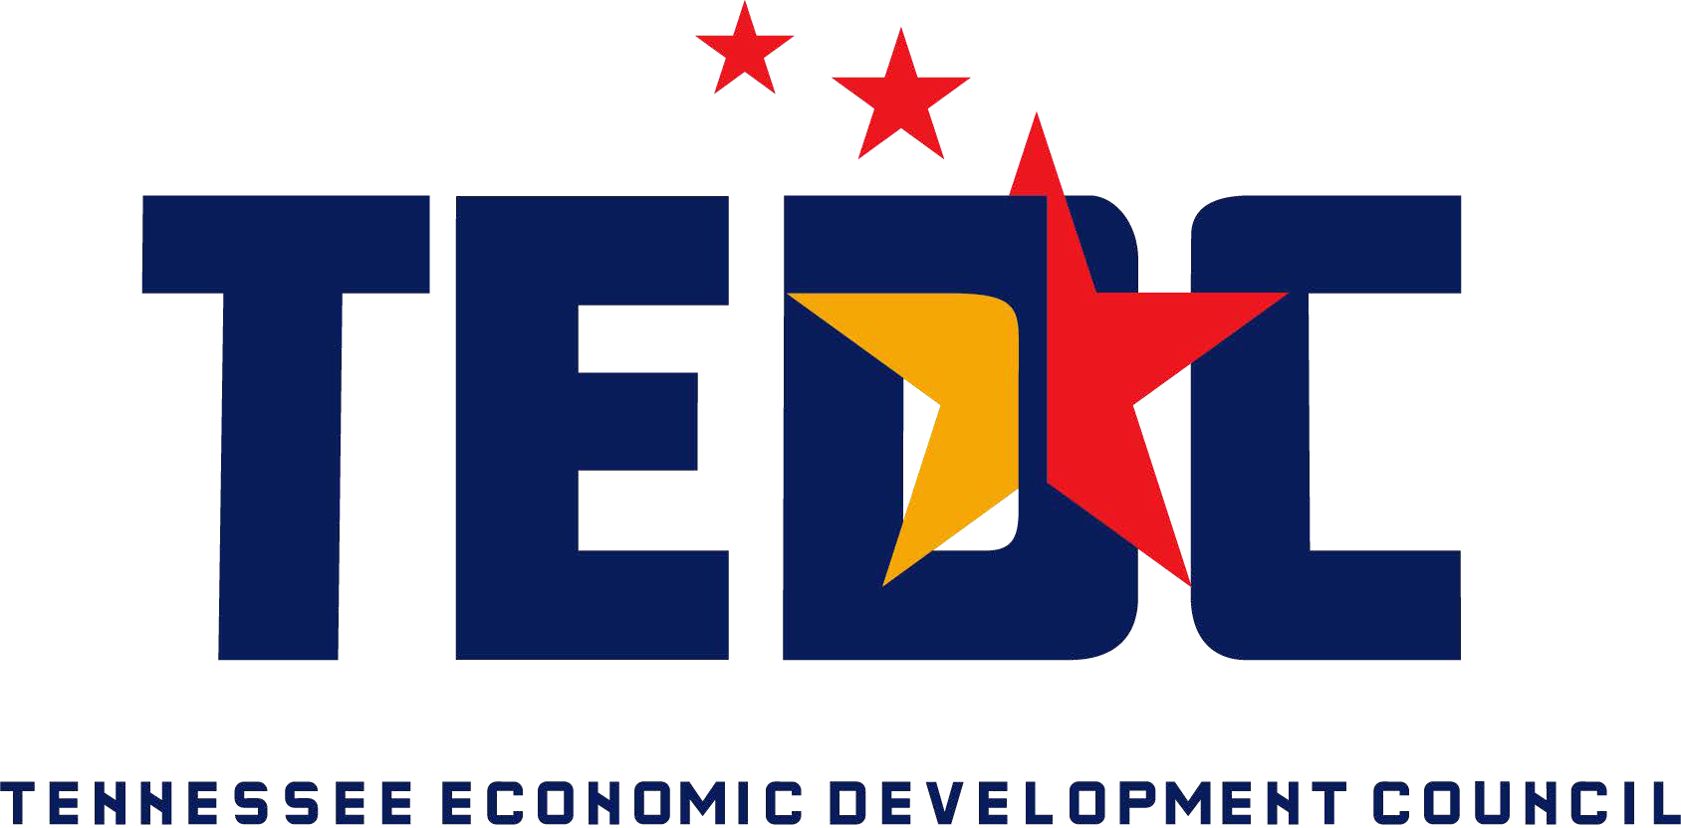**For Immediate Release**

**Media Contact**

Suzie Lusk

Phone: (615) 256-5141

[Email: suzie.lusk@tnchamber.org](mailto:suzie.lusk@tnchamber.org)

**LINDSAY FRILLING, CEO, OBION COUNTY JEDC, NAMED PRESIDENT OF STATEWIDE ECONOMIC DEVELOPMENT COUNCIL**

**NASHVILLE, TN** - The Tennessee Economic Development Council (TEDC) announces its board officers for 2022-2023. The officers were elected by the nominating committee at TEDC’s Fall Conference held in Kingsport, TN.

Lindsay Frilling, CEO, Obion County Joint Economic Development Corporation, was named TEDC’s President for the 2022-2023 year. This position comes after years of service in the economic development community.

“I am excited to serve as the President of the TN Economic Development Council as the organization has been a key resource for my professional development over the last 14 years through both educational and networking opportunities.  In my new leadership role, I am able to pay it forward by investing my time into other economic development and professional members of TEDC.  I love representing Obion County and being able to showcase our community throughout my work as an executive board member.” ~ Lindsay Frilling

The full roster of new officers are: President, Lindsay Frilling, CEO, Obion County Joint Economic Development Corporation; Vice President, Marshall Ramsey, President, Morristown Area Chamber of Commerce; Immediate Past President, Greg Lowe, Director of Economic Development, City of Lewisburg; Secretary/Treasurer, Kendrick Curtis, Assistant Director, Middle Tennessee Industrial Development Association; West Tennessee Representative, Ted Townsend, Chief Economic Development Officer, Greater Memphis Chamber; Middle Tennessee Representative, Matt Largen, President/CEO, Williamson, Inc; East Tennessee Representative, Lisa Collett, Executive Director, Morgan County Economic Development; State Liaison, Jamie Stitt, Deputy Assistant Commissioner of Business Development, TN Department of Economic & Community Development; UTCIS Representative, Beth Phillips, Economic Development Programs Manager, UT Center for Industrial Services; SEDC Representative, Charles Wood, Vice President, Economic Development, Chattanooga Chamber of Commerce; TVA Representative, Nick Cunningham, Regional Development Specialist, Middle TN, Tennessee Valley Authority.

TEDC is a statewide organization for both public and private sector professionals involved in economic development. TEDC provides professional development opportunities for its more than 425 members and works with state officials to maintain an attractive business environment in Tennessee.

For more information, visit [www.tnedc.com](http://www.tnedc.com/) or contact Suzie Lusk at 615.256.5141.

###