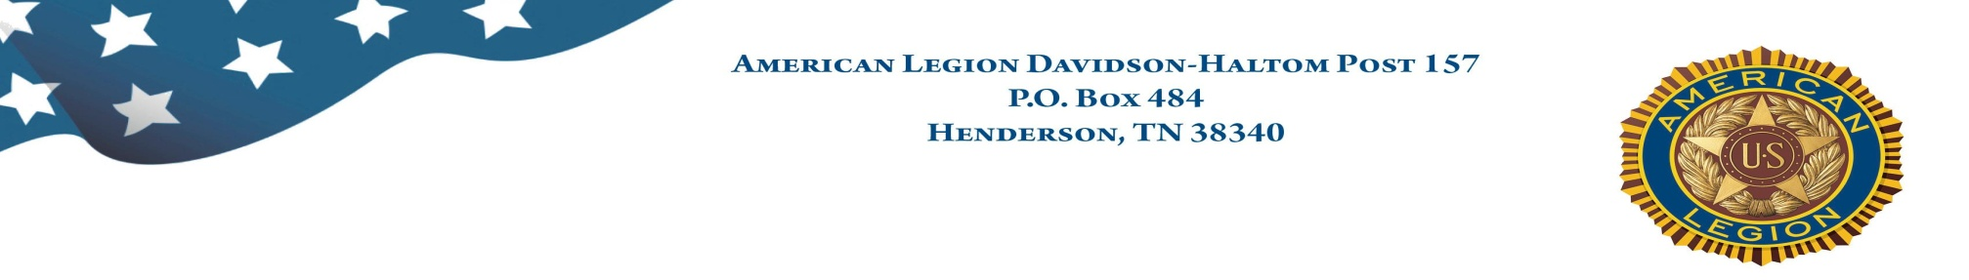

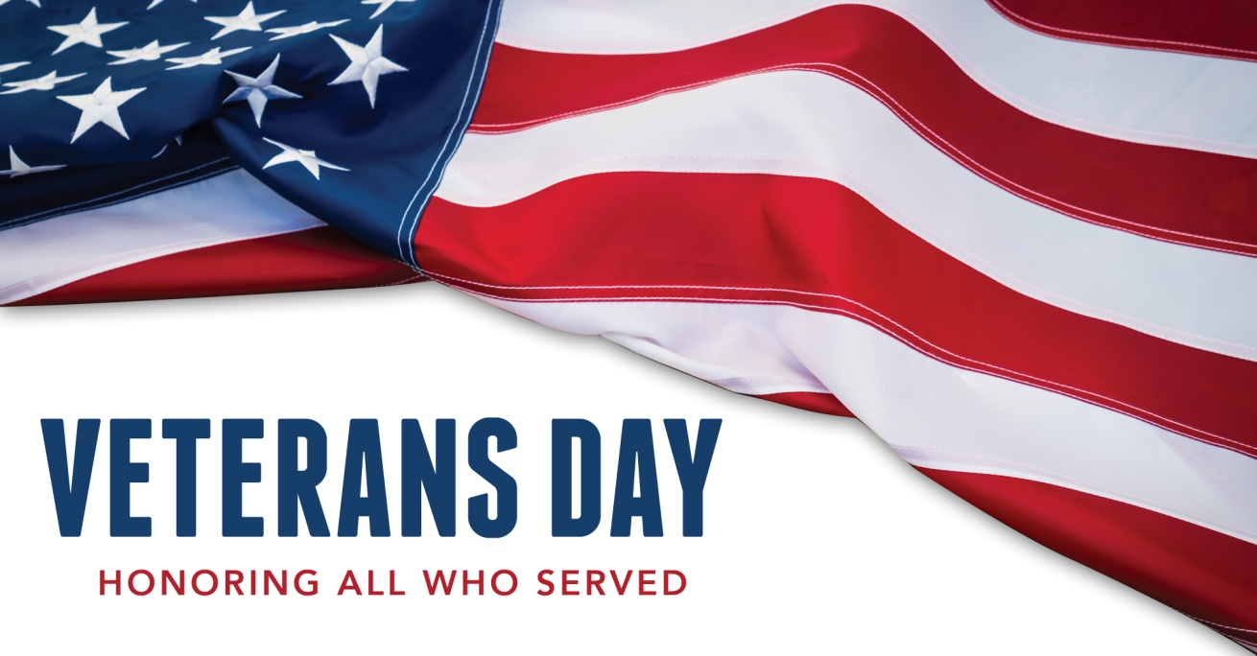

Council Chambers, 2nd Floor, City Hall, Henderson, TN

11 AM, Veterans Day, Friday, November 11, 2022

*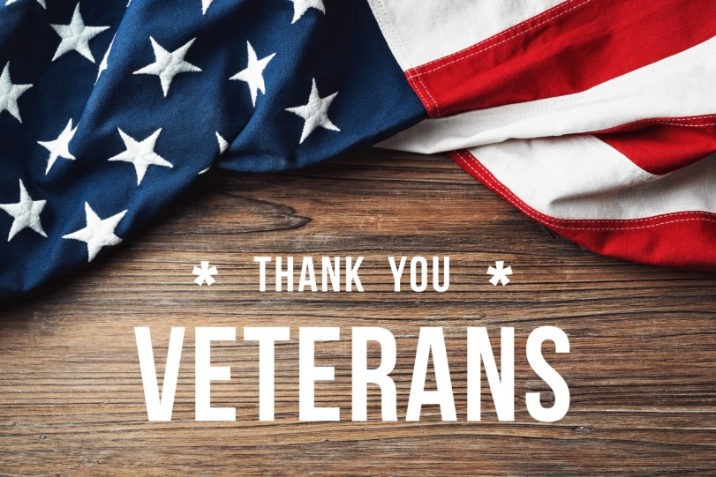*

Keynote Address by Bob Hendry, Marine Corps Veteran

Music by Ms. Lakelin Lemmings

*Hosted by American Legion Davidson-Haltom Post 157, Henderson, TN*

*Chris Dunbar, Commander*