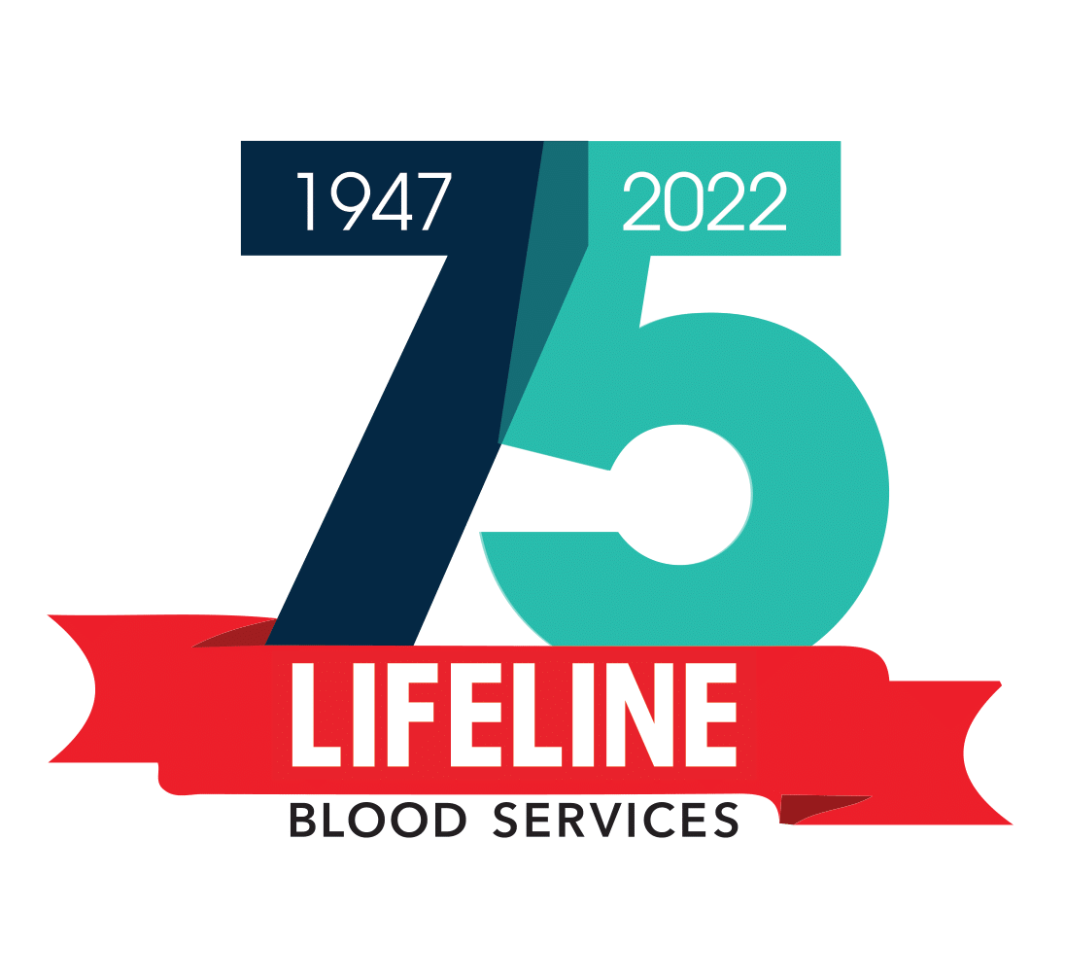

Contact:
Melinda Reid
Marketing Manager
731.427.4431 ext 106 (direct)
731.394.1919 (cell)
Melinda.Reid@lifelinebloodserv.org
Press Release
LIFELINE Blood Services Announces
their “Holiday Hero” and “Spirit of Christmas Eve” Blood Drives

JACKSON, TN: -- LIFELINE Blood Services will host their Annual “Holiday Hero” Christmas Blood Drive at their Jackson Center on December 15, from 9 a.m.- 6 p.m., at 183 Sterling Farms DR in Jackson, TN. The LIFELINE Dyersburg Center, located at 1130 HWY 51 Bypass Suite 19 & 20, will host their “Holiday Hero” Christmas Blood Drive on December 17-20. Our Dyersburg Center is open from 8 a.m. to 4 p.m. on Saturday and 10 a.m. to 6 p.m. on Sunday- Tuesday. All donors will receive a “Holiday Hero” t-shirt and a coupon for a free 10 inch pizza from Marco’s.

LIFELINE will offer a December giveaway! Upon donating at either one of our Centers or on a bloodmobile, donors can enter our drawing to win 1 of the 3 $500 VISA gift cards; one to be given away weekly from December 1- 22. On December 22, we will also draw for a 55 inch smart TV.

“We experience blood shortages around the holidays, so we especially want to ask donors to take the time to be a Holiday Hero and donate!” said Melinda Reid, Marketing Manager with LIFELINE Blood Services.

New this year, our Jackson & Dyersburg Centers will be open for “Spirit of Christmas Eve” Blood Drive. Jackson: 9am-6pm and Dyersburg: 8am-4pm. Upon a successful donation, donors will be able to choose from a list of approved local nonprofits. The nonprofit which they choose will receive a $10 donation from LIFELINE.
“Our hope is that donors will bring in their families who are in town for the holidays to donate. Also, that our partnering nonprofits will also promote and encourage their staff, board members, and constituents to come donate and that we will have a great impact on our community with our financial contributions,” shares Melinda Reid, Marketing Manager for LIFELINE Blood Services.

LIFELINE provides blood services to 21 West Tennessee counties and 14 emergency helicopter service locations. Annually, the Center collects approximately 26,000 blood products (red cell units, platelets, plasma, etc.) to meet the needs of patients. Of that total, 75% of those products are collected on the bloodmobiles across West Tennessee. LIFELINE also provides reference lab and cross-matching services to healthcare facilities. For more information, visit our website: www.lifelinebloodserv.org

# # #

