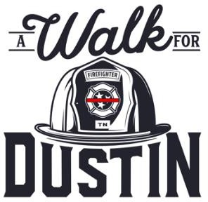 For more information:

Corey Bradford, President

Local 1850

731-695-3040

**Jackson Professional Firefighters Association Participate in “A Walk for Dustin” to Raise Awareness about PTSD and Suicide within the Fire Service and Support the Dustin Samples Act**

2/17/2023

**Jackson, TENN. –** Jackson Firefighters Association professional firefighters are joining firefighters from across the state in an event intended to shed light on an issue that tragically and frequently impacts the fire service community: PTSD and suicide.

The 2023 “Walk for Dustin” is comprised of three flags traveling across the state via firefighters and supporters gathering signatures and support for legislation currently before the TN legislature: HB976 by Garrett/SB856 by Bailey -- the Dustin Samples Act. The ultimate mission is to reduce stigma and change policy that currently acts as a barrier to firefighters seeking care after a post-traumatic stress disorder (PTSD) diagnosis. The legislation, which would update Tennessee law to ensure care under workers compensation is accessible to firefighters who receive a PTSD diagnosis, is named in honor of Captain James ‘Dustin’ Samples, a Cleveland firefighter who died by suicide in late 2020 at age 41 after 22 years of service to the Cleveland Fire Department.

**Corey Bradford, President of the Jackson Firefighters Association,** said, “As the call volume and types of events firefighters respond to have increased, so has our exposure to trauma. Working proactively to reduce stigma and improve access to effective mental health treatment early on will save firefighters’ lives. We are participating to share with our brothers and sisters that ‘it’s ok to not be ok’ and that help is available."

Captain Samples’ widow, Jennifer, now serves on the steering committee of [The 303 Project,](https://www.303project.org/?fbclid=IwAR0skAb40-V0n6dNgAKGYR1It2SkrOyzbz5utv3Qo1JRzuI5ChXxuTl-cXQ) a nonprofit dedicated to reducing the impact of mental health disorders on first responders and partnering in this walk for awareness. “Dustin was incredibly proud of the work he did and gave all he had,” **Samples said.** “It’s important to me that I honor his legacy by continuing to raise awareness for the mental health injuries that can be just as deadly, if not

more so, than the physical injuries you can see.”

“This is the number one priority for our firefighters across the state,” **said Matthew Tomek, President of the Tennessee Professional Fire Fighters Association.** “We are working to lead by example to show the next

generation of firefighters that they don’t have to pretend the traumas they are exposed to aren’t painful. We want to reduce the cultural stigma and ease the path to professional support so that firefighters can lead healthy, long lives while serving a critical role in the health and safety of their neighbors.”

# WALK FOR DUSTIN

**West Tennessee**

# WALK FOR DUSTIN

**Middle Tennessee**

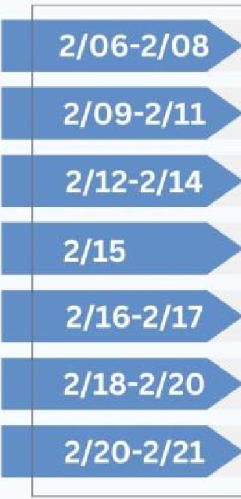

Cleveland - Local 3748 Chattanooga - Local 820 Murfreesboro - Local 3035 Spring Hill - Local 4628 Franklin - Local 3758 Clarksville - Local 3180

Nashville - Local 140

**February 2023**

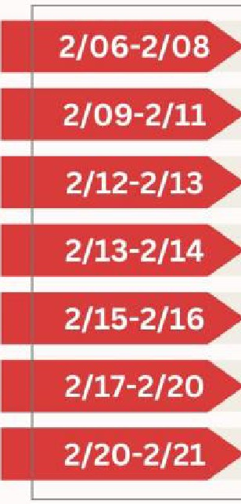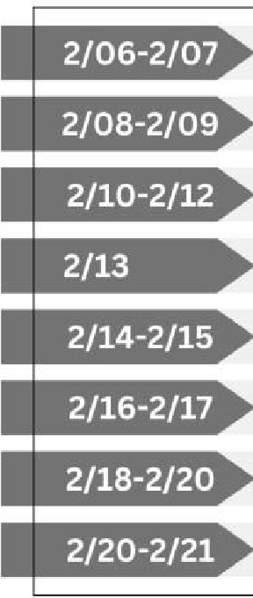

**February 2023**

**WALK FOR DUSTIN**

**East Tennessee**

Kingsport - Local 2270 Johnson City - Local 1791 Knoxville - Local 65

Oak Ridge - Local 1346 Lebanon - Local 4144 Wilson Co.- Local 4238 Hendersonville - Local 3460

Nashville - Local 140

Memphis - Local 1784 Shelby Co. - Local 2585 Collierville - Local 3864 Germantown - Local 3858 Atoka - Local 5110 Jackson - Local 1850

Nashville - Local 140

**February 2023**