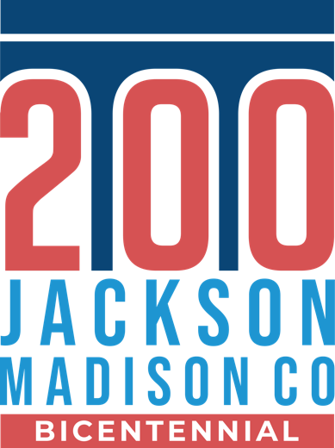**Press Release**

**FOR IMMEDIATE RELEASE**  
February 8, 2024

**Contact:**   
Leigh Anne Bentley  
Bicentennial Commission Marketing Chair  
664.1784 ext. 1121  
[lbentley@leaderscu.com](mailto:lbentley@leaderscu.com)

Jacksonmadison200.com

**Connecting Through the Centuries:   
Bicentennial Park Begins Construction**

JACKSON, Tenn. – The Bicentennial committee is thrilled to announce a significant milestone in one of their most prominent legacy projects. Phase 1 of construction has started with the installation of the wall at Bicentennial Park located at 345 West Main Street in downtown Jackson. Bicentennial Park, inspired by the Bicentennial’s theme of “Connecting Through the Centuries,” is set to become a timeless symbol of rich history and the enduring legacy of the people and events in Jackson and Madison County.

“The Bicentennial Park wall is more than just bricks and mortar,” said Elaine Christian, Bicentennial Chair. “It’s a living monument to our shared history and marks the beginning of the construction of our park. The park will stand as a testament to the unity and resilience of our community across two centuries and set the stage for the future.”

As the wall takes shape, the Bicentennial Committee looks forward to the next steps in this historic project. The Bicentennial Park is being constructed by MSB Construction Company. TLM Associates is the design engineer for the park. Both companies are renowned for their commitment to quality and precision in architectural projects. The next steps include groundwork and artwork installation.

Legacy projects include the “Milestone” history book, commissioned paintings at City Hall by Lendon Noe, commissioned paintings at the Madison County Courthouse by Caleb O’Conner, and the Jackson-Madison County time capsule at Bicentennial Park, are part of the initiative to leave a lasting impact on future generations. These projects are made possible by the Bicentennial’s sponsors, including legacy sponsors City of Jackson, Madison County, Jackson Energy Authority and West Tennessee Healthcare.

For more information about the construction of the Bicentennial Park and other legacy projects, visit <https://jacksonmadison200.com/>

-###-