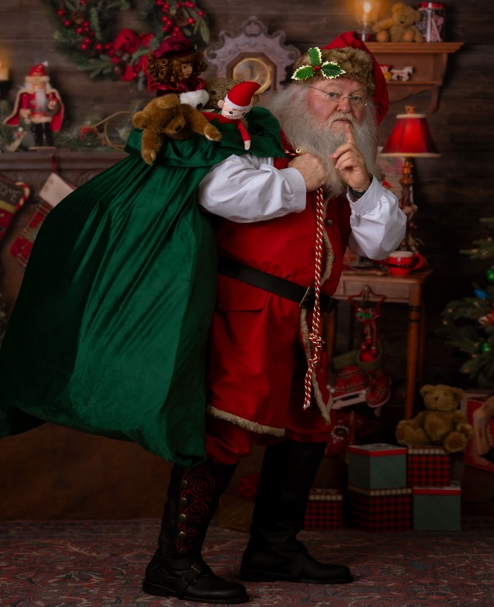
Santa is coming to
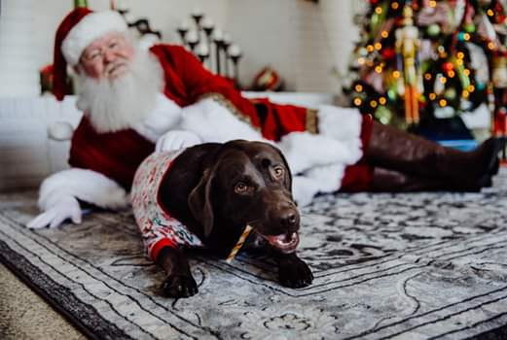

Free Santa Photos & Toy Drive
Sunday, November 16
1pm -5pm
Pets welcome after 3pm

In exchange for photos with Santa we ask that you bring a toy for the children
at Lebonheur or the puppies at the Jackson Animal Care Center.

Food trucks will be on site!

Home2 Suites
40 Old Medina Crossing
Jackson, TN 38305

